Step To create React App

1. Install Node in your computer by visiting <https://nodejs.org/en/download>
2. Test the installation of node by the typing the command node –v in command prompt as show below

Microsoft Windows [Version 10.0.22621.2134]

(c) Microsoft Corporation. All rights reserved.

C:\Users\Administrator>node -v

v14.16.0

C:\Users\Administrator>

1. Check for npm (Node Package manager is bundled with node) type the command npm –v

C:\Users\Administrator>npm -v

6.14.11

1. Type the command npx create-react-app first-app to create react application as shown below

npx create-react-app first-app

D:\DJango Tutorial\MoviewRaterReact>npx create-react-app first-app

npx: installed 67 in 5.526s

Creating a new React app in D:\DJango Tutorial\MoviewRaterReact\first-app.

Installing packages. This might take a couple of minutes.

Installing react, react-dom, and react-scripts with cra-template...

Success! Created first-app at D:\DJango Tutorial\MoviewRaterReact\first-app

Inside that directory, you can run several commands:

npm start

Starts the development server.

npm run build

Bundles the app into static files for production.

npm test

Starts the test runner.

npm run eject

Removes this tool and copies build dependencies, configuration files

and scripts into the app directory. If you do this, you can’t go back!

We suggest that you begin by typing:

cd first-app

npm start

Happy hacking!

1. To run the app in development environment just go to the first-app folder and run the following command as follows

D:\DJango Tutorial\MoviewRaterReact>cd first-app

D:\DJango Tutorial\MoviewRaterReact\first-app>npm start

This will start the app as follows

Compiled successfully!

You can now view first-app in the browser.

Local: http://localhost:3000

On Your Network: http://172.28.240.1:3000

Note that the development build is not optimized.

To create a production build, use npm run build.

webpack compiled successfully

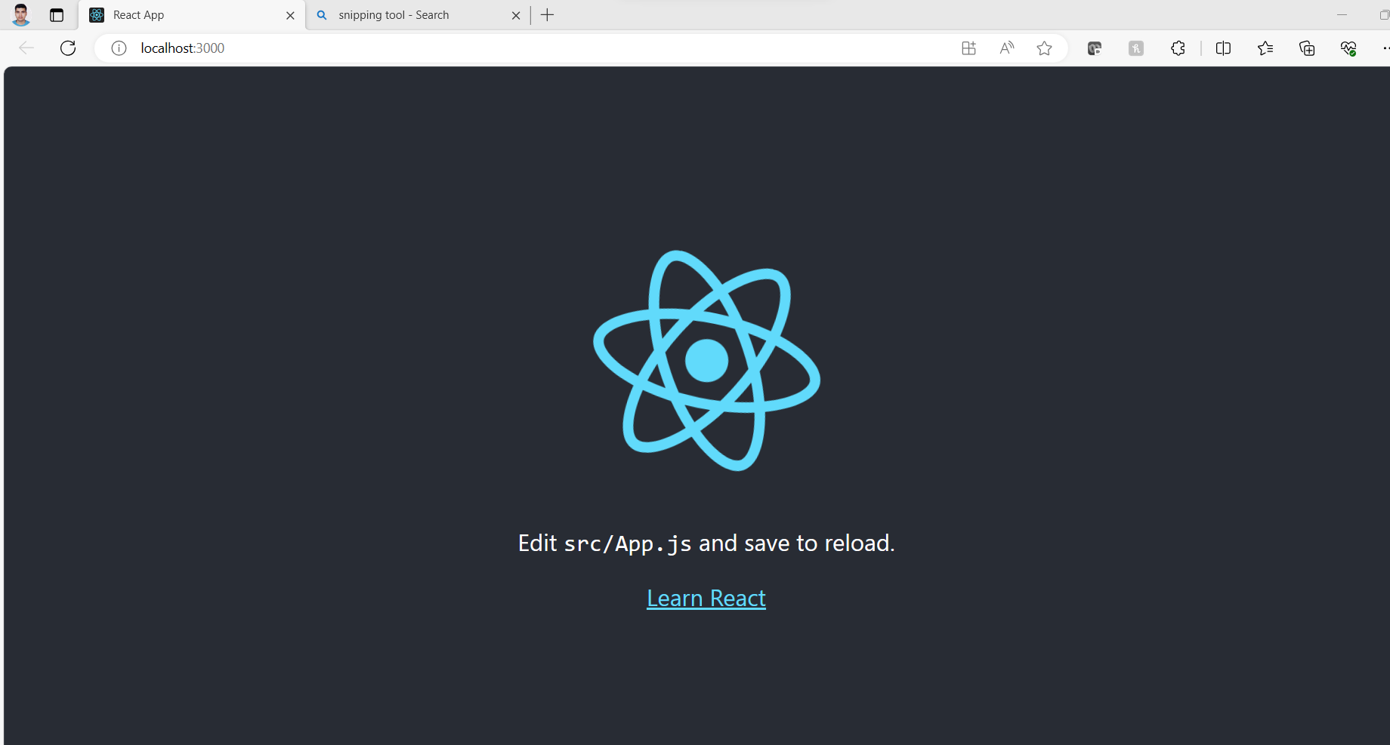

1. Open the app in Visual Studio Code as follows

